**Installation**

1) Download NodeJS from this link <https://nodejs.org/en/download/>. Select Windows Installer (.msi) for the correct version of Windows (check if you are using 32-bit or 64-bit Windows)

2) Launch the downloaded NodeJS installer

3) Go through the setup (Just click next. No need to change any settings)

4) Click finish when setup complete

5) Download MongoDB from this link <https://www.mongodb.com/download-center?jmp=nav#community>. Click the download button

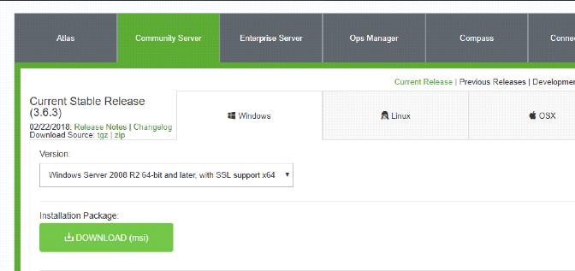

6) Launch the downloaded MongoDB installer

7) Click next

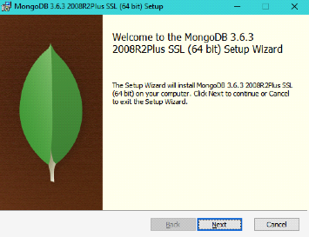

8) When this screen comes click complete and then Next

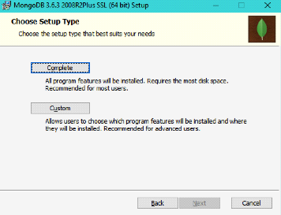

9) No need to install MongoDB Compass. Uncheck the box in bottom left.

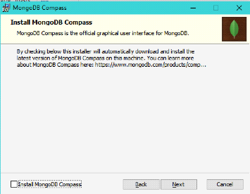

10) Install and when completed click Finish

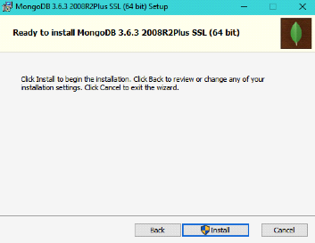

11) Go inside the FYP folder

12) double click install.bat A terminal will popup. Wait for all the things to finish installing. The terminal will exit automatically after installation completes

**Launching application**

1) double click start-database.bat A terminal will popup starting the database

2) double-click start.bat Wait for a while the site will startup automatically